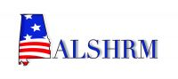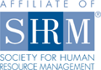
ALSHRM Legislative Symposium
February 16th, 2017

Registration & Breakfast 7:30am – 8:30am
“The 115th Congress and the Trump Administration:
the Washington Outlook for HR Public Policy”
Mike Aitken, VP of Government Affairs, SHRM 8:30am – 9:45am

Break 9:45am – 10:00am

“The Alabama State Legislature, Workers Compensation and You”
Senator Arthur Orr 10:00am – 11:15am

Lunch 11:15am – 12:15pm

Meet and Walk to Capitol Building 12:15pm – 1:00pm

An Afternoon at the Capitol 1:00pm – 4:15pm

Reception/Networking Event 5:00pm – 6:30pm

Thank You to Our Sponsors!!
Payroll Services, LLC 